**Newton’s Second Law of Motion**

**Pre-lab questions**

1. What is the goal of this experiment? What physics and general science concepts does this activity demonstrate?
2. What is the mathematical expression for Newton’s Second Law of Motion?
3. How will error in measuring time (*t*) affect the calculated acceleration of the system?
4. In a real experimental Atwood’s machine, the presence of friction cannot be completely eliminated. How will this change the measured acceleration due to gravity?

**Introduction**

The goal of the experiment is to verify that acceleration of mass is linearly proportional to the unbalanced force acting on it, with accordance to Newton’s second law of motion. For this you will use a mass-pulley system known as an Atwood’s machine. From this experiment you will be able to determine the acceleration due to gravity.

Simple Atwood’s machine consists of light low friction pulley rigidly mounted, and two masses connected by a light string passing over the pulley, as shown in Figure 1.

If these two masses are equal, the system is in equilibrium, and ***T*** is the tension in the string that balances the weight of masses.

If you transfer a small part from one mass to another, the unbalanced force arises from the difference in weight given by the differences in masses, and this unbalanced force causes system to accelerate. The larger massm1 start to move downward and the smaller m2will move upward with the same acceleration **a**, as shown in Figure 1.

Remember that near the surface of Earth weight (***W***) is a force given by:

$$\begin{aligned}W=m*g\#\left(1\right)\end{aligned}$$

These forces are indicated with arrows in Figure 1. Notice that the arrows originate on the object on which they act, point in the direction in which they act, and have sizes relative to their magnitude. Acceleration is not a force, but it is a vector, so it is also represented with an arrow here to indicate direction.

Newton’s Second Law should be written separately for each object of interest. It can be written generically as the sum of all forces acting on an object will tell us how the mass of that object is accelerated. This sum is a vector sum, which means that we need to decide on a coordinate system and split the sum into a collection of 1-dimensional problems. Mathematically, we write this as:

$$\begin{aligned}{\vec{F}}_{net}=\sum{\vec{F}}=m*\vec{a}\#\left(2\right)\end{aligned}$$

The Greek letter sigma (*∑*) indicates summation; the arrows indicate which variables are vectors.

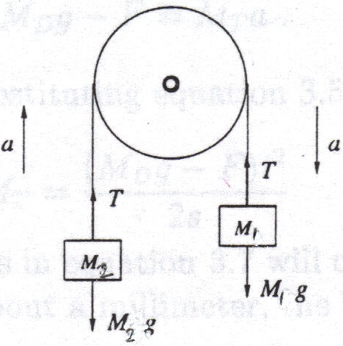

Figure 1. Atwood’s Machine

Ignoring the friction force in a pulley, let’s apply the Newton’s Second Law to the larger mass m1. Let’s working in the up-down dimension, and we will choose the direction of expected acceleration to be positive. $\begin{aligned}m_{1}g-T= m_{1}a\#\left(3\right)\end{aligned}$

Similarly, the equation of forces for the smaller mass m2 is:

Again, we have decided that the direction of acceleration is positive. Because we do not expect the string to stretch or compress, we can assume that the acceleration of mass 1 and the acceleration of mass 2 are the same. Thus, we do not need to include a subscript to distinguish ***a*** in either equation. We will also assume that the string is relatively massless when compared to the hanging masses, so the force of tension (***T***) in the string is the same for both equations.

Adding equations (3) and (4) gives:

$$\begin{aligned}m_{1}g-m_{2}g=m_{1}a+{ m}_{2}a\#\left(5\right)\end{aligned}$$

Rearranging equation (5):

$$\begin{aligned}g\left(m_{1}-m_{2}\right)=a\left(m_{1}+m_{2}\right)\#\left(6\right)\end{aligned}$$

Let’s rename the **difference in masses**: $\left(m_{1 }- m_{2} \right)=Δ m$

and the **sum of masses**: $(m_{1} + m_{2} ) = m_{Σ}$

We can rewrite the equation (6) using these symbols:

$\begin{aligned}g Δ m = a m_{Σ}\#(\end{aligned}7)$

This equation can be used to find the acceleration due to gravity **g** if the acceleration of system **a** is known from the experiment:

$\begin{aligned} g = a \frac{m_{Σ} }{Δm}\#\left(8\right)\end{aligned}$

**The acceleration of the system $a$**  can be found by measuring the time *t* when the system of mass m moves down over a known distance *d*. The distance that object moves when released from rest (*v0* = 0), is given by general equation of motion with constant acceleration:

$\begin{aligned}d = ½ a t^{2}\#\left(9\right)\end{aligned}$

You can calculate the acceleration of system using this equation when distance d and time t are known:

$\begin{aligned}a = {2 d}/{t^{2}} \#\left(10\right)\end{aligned}$

If you use a small difference in the masses ($Δm$) it will result in a significantly reduced acceleration when compared with $g$. Since acceleration is relatively small it is easy to measure using a stopwatch and a meter stick. We can also use the PASCO measurement system to plot velocity as a function of time and find the acceleration from the slope the plotted line.

Measuring acceleration allows us to calculate ***g*** using equation (8). However, in a real experimental system the presence of friction cannot be eliminated completely. Friction will contribute to your experiment by reducing the acceleration of the system. You can evaluate its contribution by comparing the experimental value for acceleration due to gravity with the known value $= 9.8 m/s^{2}$.

In this experiment, you will measure the acceleration of mass acting upon by unbalanced force. To vary the unbalanced force, you will keep mass of system $m_{ }$ constant and vary mass $Δ m$ by transferring a small part of mass from one hanger to another. This unbalance force makes the system accelerate, and you can find the acceleration $a$ measuring distance *d* and time *t* during experiment. Since the acceleration varies as $\left(\frac{1}{t^{2}}\right)$, any relative error in measuring *t* will be doubled.

Instead of measuring *d* and *t*, we use the PASCO measuring system to determine ***a*** from a plot of velocity as a function of time and then calculate an experimental value for ***g***.

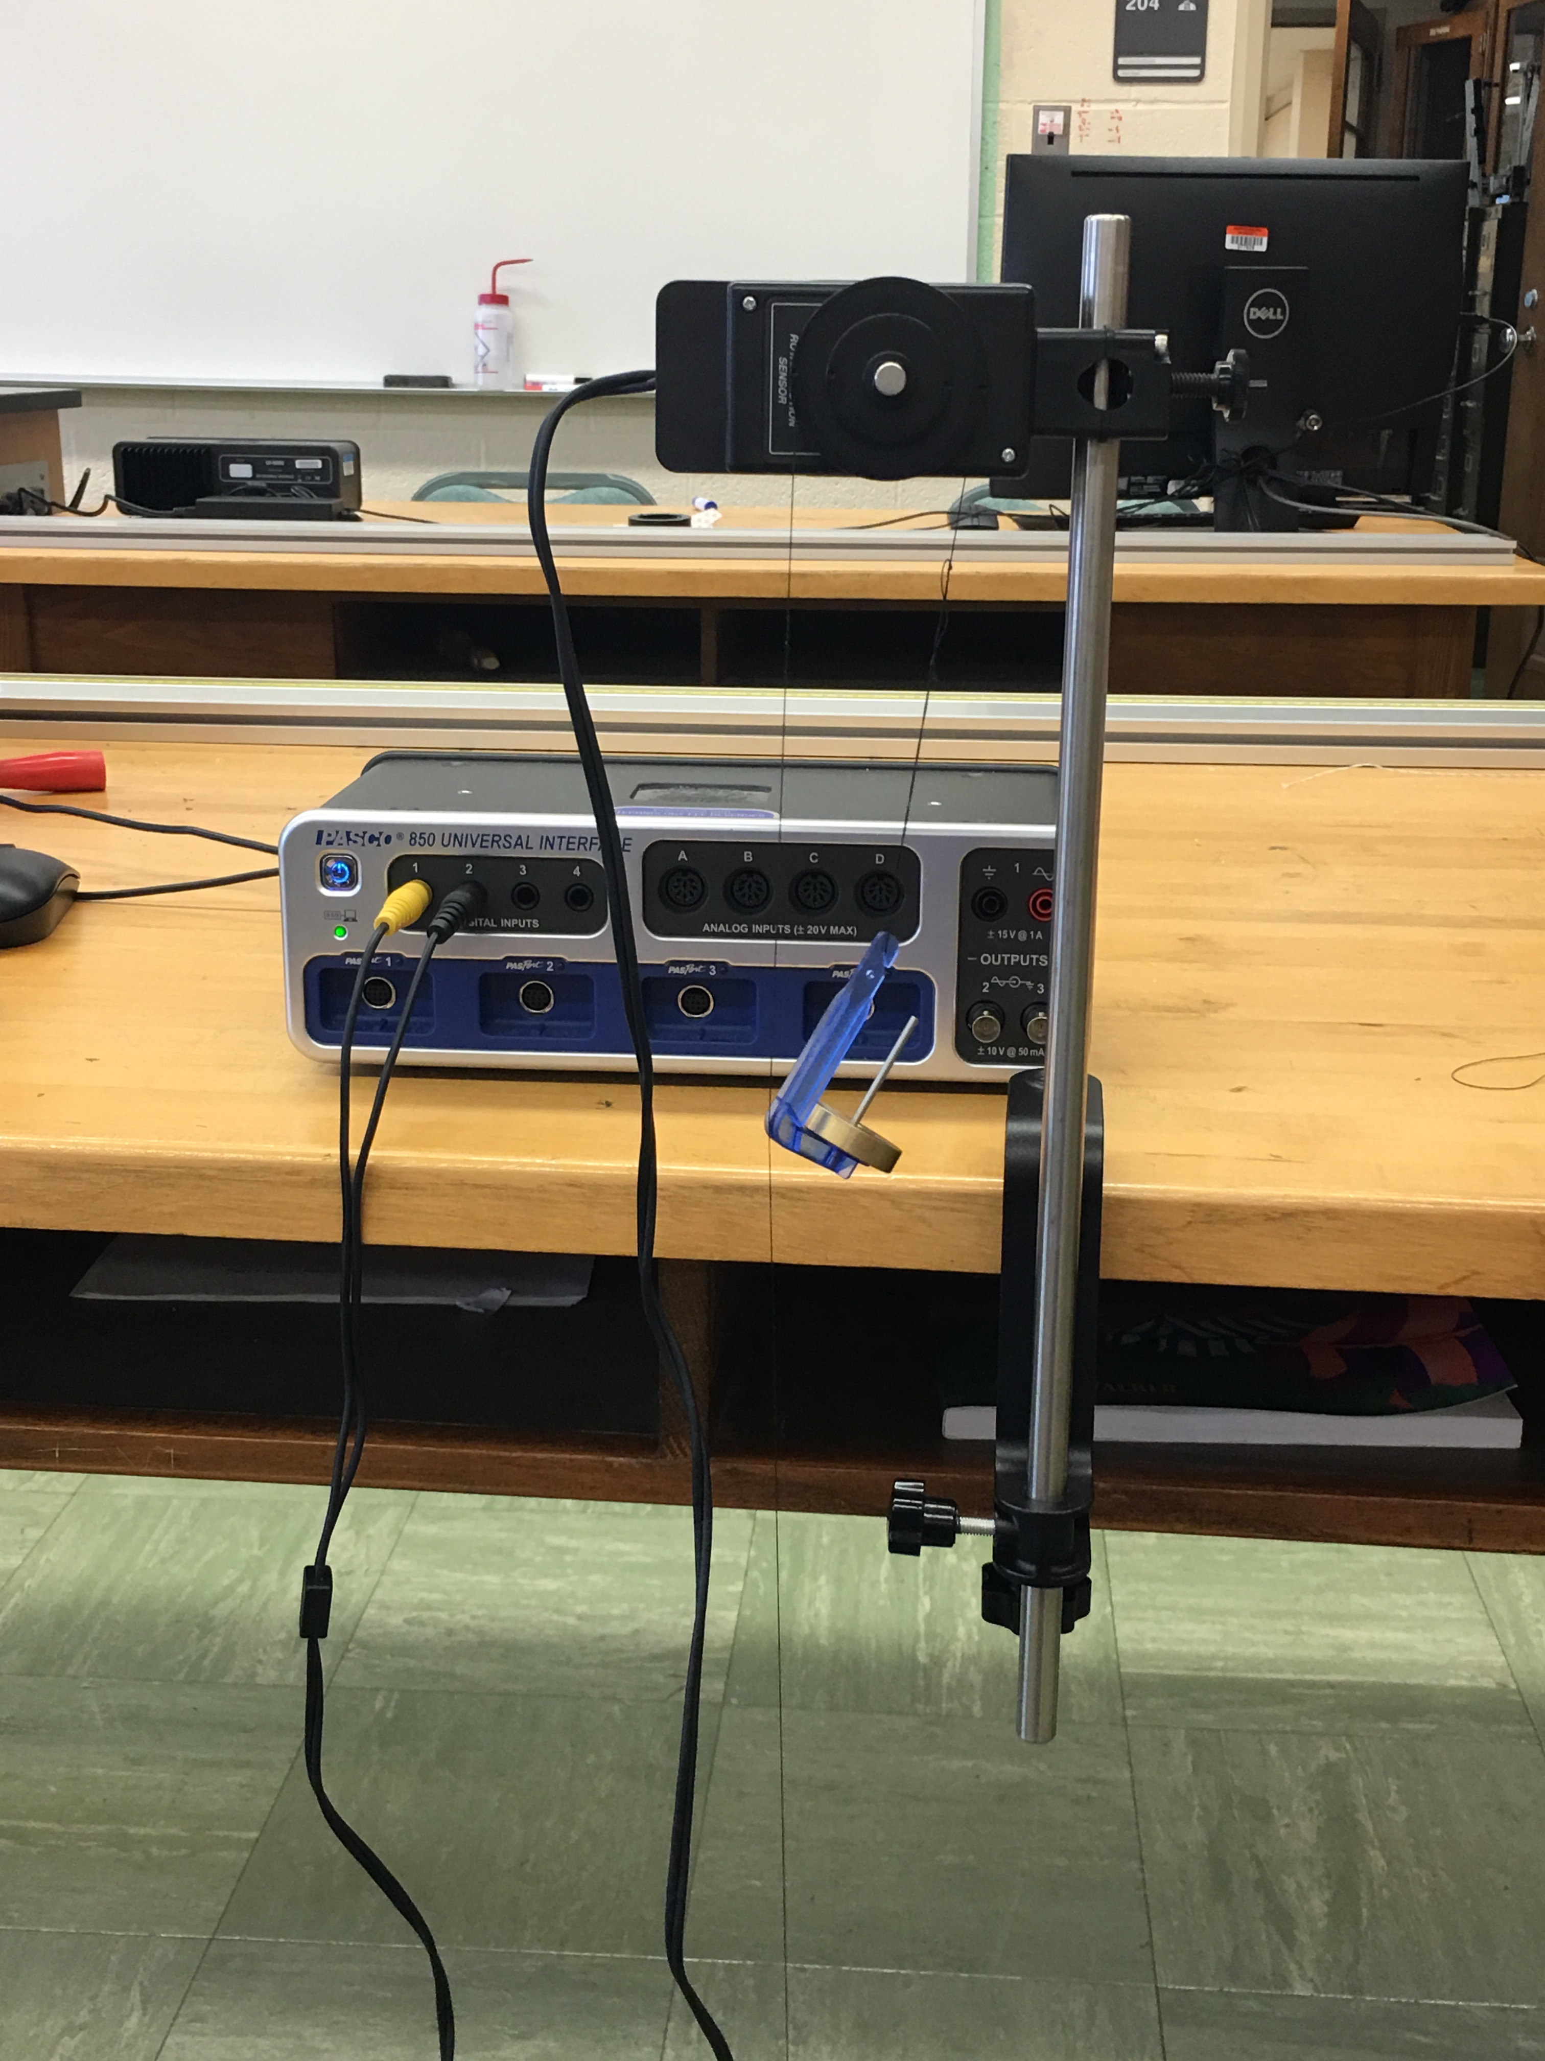**Equipment:**

* table clamp
* rod
* PASCO Rotary Motion detector
* two mass hangers (5 g each)
* slotted masses
* thread about 1 m long

Figure 1: Atwood machine equipment setup.

**Experiment**

For this experiment, mass $m_{Σ }$ is kept at 100 grams and mass $Δ m$ will vary from 2 grams to 10 grams.

* Start PASCO software for data collection.
  + In the hardware setup window select the rotary motion detector.
  + Increase acquisition rate to set the detector to maximum sensitivity.
  + Click on the properties button image.png and select the “large pulley – in the groove” setting.
  + Choose an experiment with a graph. Select “velocity” for the y-axis and “time” for the x-axis.
* Suspend the pulley system as high as practical. Connect two mass hangers by means of a long string and pass the string over the big pulley. The string should be long enough for one hanger to reach the floor when the other is at the pulley.
* Load one hanger with a total of 50 grams using a variety of slotted masses including some of the 1 and 2 gram masses (remember that the hanger itself is already 5 g). This hanger will act as mass m1. Load the second hanger m2 with a total mass of 50 grams. You will be able to transfer small 1 or 2 gram masses between the hangers to complete each trial of the experiment.
* With hanger m2 near the pulley and the other hanger m2 on the floor, transfer 1 gram from m1 to m2. Record new masses m1 = 49 g and m2 = 51 g in the data table and calculate the mass sum m and mass difference m.
* With smaller mass m2 on the floor, start the data collection on the computer using the “record” button. Release the mass system just after beginning recording and stop it when the hanger reaches the floor. Catch the system before impact to avoid damaging the masses.
* Due to limitations of the equipment (the data rate for the Pasco equipment is limited so it possible to exceed the collection rate if the pulley wheel spins to fast) or possible collision of the hangers you may not get a full data set to the floor. Adjust the data rate if your computer produces an error. Re-run the trial if mass hangers collide.
* Look at the run data using the graph to view. Because this is motion in one dimension under constant acceleration, we are looking at a graph of velocity as a function of time:
$$\begin{aligned}v\left(t\right)=v_{0}+at \#\left(11\right)\end{aligned}$$

* The slope of this graph would be described as $\frac{Δv}{Δt}$, which is the definition of average acceleration.
  + The mass was released from rest, so $v_{0}=0$. However, the graph may be a bit offset in time due to starting the data recording a bit before the mass was released.
  + We are interested in the straight-line portion of the graph that shows velocity increasing from zero to some maximum before the heavier mass reached the floor. This straight-line is mathematically described by equation (11). The slope of the straight line is the acceleration “***a***”.
  + Use the graph tools within PASCO to highlight only the data for the straight-line portion of the graph. Then use the graph tools to find the equation for the line of best fit for this data. Record the slope of this line as your experimental acceleration “***a***”.



Figure 2: PASCO highlight tool - used to highlight relevant data.



Figure 3: PASCO slope tool - used to create line of best fit with equation.

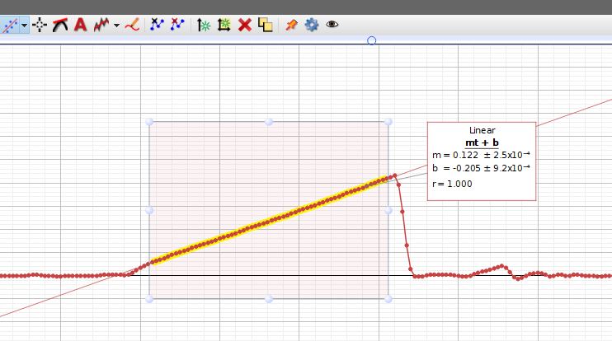

Figure 4: Example PASCO graph of velocity vs. time with line of best fit for highlighted data.

* + Use equation (8) to calculate an experimental value for the acceleration due to gravity ***g***.
  + Calculate the difference between this experimental value and the actual accepted value of $g=9.81 m/s^{2}$ and include this data
* After each run, check that the string is still in grove of the large pulley.
* Repeat step 5-7 for each of the masses transferred from the second hanger m2 to the first m 1: 2 gram, 3 gram, 4 gram, 5 gram. Do multiple trials for each pair of masses, filling in the data table.
* Check that you have included proper units in all of you data records.

# Data Table: measured and calculated data

|  |  |  |  |  |  |  |  |  |
| --- | --- | --- | --- | --- | --- | --- | --- | --- |
| *Trial* | *m1* | *m2* |  |  | *a* | *g (calc)* | $$Δg$$ | $$(Δ{g)}^{2}$$ |
| 1 | 49 g | 51 g | 2 g | 100 g |  |  |  |  |
| 2 | 49 g | 51 g | 2 g | 100 g |  |  |  |  |
| 3 | 49 g | 51 g | 2 g | 100 g |  |  |  |  |
| 4 | 48 g | 52 g | 4 g | 100 g |  |  |  |  |
| 5 | 48 g | 52 g | 4 g | 100 g |  |  |  |  |
| 6 | 48 g | 52 g | 4 g | 100 g |  |  |  |  |
| 7 | 47 g | 53 g | 6 g | 100 g |  |  |  |  |
| 8 | 47 g | 53 g | 6 g | 100 g |  |  |  |  |
| 9 | 47 g | 53 g | 6 g | 100 g |  |  |  |  |
| 10 | 46 g | 54 g | 8 g | 100 g |  |  |  |  |
| 11 | 46 g | 54 g | 8 g | 100 g |  |  |  |  |
| 12 | 46 g | 54 g | 8 g | 100 g |  |  |  |  |
| 13 | 45 g | 55 g | 10 g | 100 g |  |  |  |  |
| 14 | 45 g | 55 g | 10 g | 100 g |  |  |  |  |
| 15 | 45 g | 55 g | 10 g | 100 g |  |  |  |  |

**Computations and Analysis**

1. Calculate the acceleration due to gravity $g$ from equation (5) and record it in table for each of the experiment.
2. Calculate the average $g_{av}$ and estimate the uncertainty in the average by calculating the standard deviation of the mean $σ_{m}$:

$g_{av} =\frac{ g_{1}+ g_{2} + g_{3} +....+ g_{n}}{n} = \frac{\sum{g_{n}}}{n} =$

${σ }_{m} =\sqrt{\frac{\sum{{(Δg)}^{2}}}{n (n-1)}} =$

where n -is the number of trials.

1. Present your result as: $g= g_{av} ±{σ }_{m}$ with the correct number of significant figures and units:
2. Calculate the percent difference between your average and known value for gravity acceleration = 9.80 m/s2.

Percent uncertainty: $\frac{σ_{m}}{g_{av}}×100\%=$

1. Plot a graph showing the dependence of the acceleration [y-axis] on the unbalanced force [x-axis]. Do this either with the attached graph paper or computer software.

* The unbalanced force is $F = Δm g$– use g = 9.81 m/s2.
* 1 N of force is equal to 1 kg*m/s2
  1. Is this graph a straight line?
  2. If so, does it mean that unbalanced force and acceleration are directly proportional to each other? Write the equation:

[hint: look back to the equation in the introduction]

* 1. You can find the mass of the moving system from your graph. Do it and compare the result with your experiment:

Acceleration [m/s2]



Force, [N]

Evaluate the mass of the moving system from the slope of the graph.

1. Evaluate the force of friction in the pulley and coefficient friction from your data.
   1. The difference between the experimentally found gravity acceleration $g_{av}$ and known gravity acceleration g = 9.80 m/s2 originates from neglecting the force of friction acting in the pulley. This difference ($9.80 - g_{av}$) shows the contribution of friction force into experiment and is proportional to the friction force: $\begin{aligned}F_{fr} = \left(9.80 – g_{av} \right) \frac{∆m}{2}\#\left(12\right)\end{aligned}$

where $Δm = (m_{1} – m_{2})$ is the difference in mass related to the force that accelerates the pulley system.

When making this calculation of the friction force $F_{fr}$ use data from trial 15, which corresponds to the largest value of m in your experiment. Remember that force in units of Newtons requires mass in kilograms and acceleration in meters per second squared.

Result: $F_{fr} =$

1. The force of friction is proportional to a normal force N, which for a pulley is: $N = g \left(m_{1} + m_{2}\right)$.

$$\begin{aligned}F_{fr} = μ N = μ g \left(m_{1} + m_{2}\right)\#(13)\end{aligned}$$

You can evaluate a coefficient of friction in the system from this equation:

$\begin{aligned}μ =\frac{F_{fr}}{g \left(m_{1} + m_{2}\right)} \#\left(14\right)\end{aligned}$

Calculate the coefficient of friction in the pulley system.

Result: $μ =$

Is this result reasonable? Use your text or other resources to compare it to other “low friction” items.

**Include conclusions and source of errors in lab write up.**